Requirement discussion with Colin

1. In “Building a call sheet process”,  “Only Multiwell programmed call sheets should be cloned. All other call sheets must be created from a program. “

What makes differences between “Clone from existing Call Sheet” and “Create new call sheet from same program”?   Cloning the call sheet brings over some other information such as directions, client, rig, special instruction etc.

1. What does OSR mean? On Site Representative (Sanjel word for the client rep)
2. For one single well, when client calls us, which of followings will be given us as unique identifier.
   1. Well Location (Downhole), I think this maybe, but if the down hole location can be unique? Yes
   2. Well Name Yes
   3. Well License Number No
3. What does HOS mean?
4. How do you use Google Map to estimate travel time? Do you convert well location to latitude/longtitude?  Yes, we can either use a website called rig locator, or we can use a service that converts LSD to grid coordinates which we can plug into Google maps
5. What does crew reset mean? What are criteria of reset complete? Criteria is basically the Hours of Service regulations.  In most cases it just means a crew either needs 8 or 10 hours off before they can begin their next shift.
6. Who is the convoy leader?  Usually the supervisor, but if no supervisor is present then its just the senior employee on the trip.
7. Is the JMP logbook a paper book today? Yes, but the guys in the field complete it and send it via scanner to us for review.

Oct 12 Discussion with Craig

1. If you get a call from a new client, you will pass the information to Client Solution for further conversation. Do you add this rig in Rig Board? If not, when will it be added to Rig Board and who will trigger it?

Typically we would add them to the rig board right away so we do not forget about the call/job.  We generally try to accommodate all the work we can, so odds are we will do a job for that client if they call in, if not we can simply delete them off the board later.

1. While you are taking the call and get all information you need, do you look at crew and unit availability at same time to see if we can go for clients job? Or you will look at the availability later?

Usually calls are made in advance to tell us when a job is up for a “rough estimate” on time, for those calls we don’t usually plan a crew unless it is for dedicated crews or for a crew going to camp for an extended period of time.  And then the OSR will call again and give us a confirmed final time to be on location, at that point we will plan a crew to go out if we haven’t planned it already.

Sometimes an OSR will call with very minimal notice for a job, and we would need to call crews within a few hours.  In this situation we would try to tell the OSR if we would be on time or if we would be late.

In general it’s a good idea to always be planning a crew to go for a job that calls in no matter when it is, but don’t tell the OSR that crew is guaranteed.

1. Can you explain the colors of Date column in Rig board? And also in Hauls column and Bins Column.

This is a legend for the truck list board on the west side:

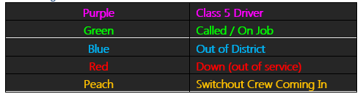

It is a little different for the rig board:

Yellow is used for “notes” on the rig board.  For example if a customer wants 30t for a job we will say “30t confirmed – needs hauls” to say we need to haul cement to the location prior to the job.  It is also used to bring notice to all dispatchers about important information they may need, for example if an OSR requests we chain up the truck tires before we go into location:

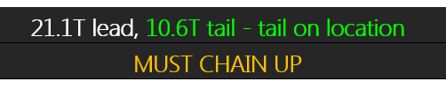

Green is used to say a time on location is confirmed, while red is used to say a job is expected to come up for a given day but not confirmed yet

The east and west board are a bit different from one another, but I personally like the west board better.  One thing the west does is highlight cement that has been shipped to location in Green text to say it is on location, for example:

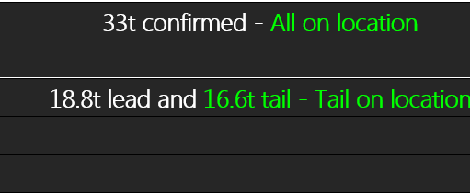

White is used for just general text, and if a job date is in white text the job is complete

Another nice thing about the west side board is they highlight when a crew is called for a job by changing the background colour on the confirmed time on location, for example:

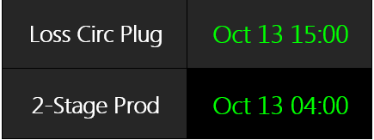

And the last colour on the rig board to worry about is high profile jobs, where we change the background colour in the Job column, for example, the 2-stage production is a high profile job:

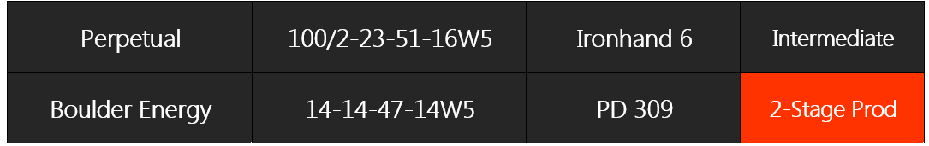

The BIN column is for rigs that have either a p-tank or a mega silo on location.  A number in that column shows which p tank or mega silo number is on location.  For the west board: a green number means the p-tank is on location and the ptank number has been confirmed.  A white number means the p tank is on location but we are not 100% sure what number the ptank is.  And question marks or NEED means we need to send a ptank to that location.

The hauls column is where we put the info for how much cement is required for a job, and its also where we put all other information that is relevant.

1. In current process, when client call in for final notice, you will update call sheet to make it ready.  So in the call sheet Call out section, “Call Date/Time” is Client call-in time, “Requested Date/Time” is expected on location time. So when should you call out Crew time is not there, and you will put reminder in Dispatcher Outlook Calendar. Is that right?

No one uses the outlook calendar that I know of; some people set alarms on the iphones when to call crews, others can just remember when to call them.  But a feature that once you confirm an on location time would ask you when to call crews that would also act as a reminder (or alarm) would be nice.

Oct 13 Discussion - Craig

1. Do you have awareness of COD customer in dispatch process?

We have it pop up on eservice.  When that does come up when building the callsheet we would notify the client solutions rep

1. In rig board, your tracking product haul status. When a cement amount is entered in call sheet, it is considered “confirmed”. By the moment, do you know if it needs a haul or not? If it needs a haul, do you know what hauling equipment needed? I am thinking if we can use “Hauling Equipment” to indicate the needs of hauling.

To determine if a job needs a haul or not we generally look at whether the order will fit on one bulk truck.  There is no standard for whether it needs a haul or not, we just use our judgement on if its worth doing.  Typically it’s always a good idea to have the cement on location if we can get it out there before, that way it doesn’t become an issue if we are busy and have no spare bulkers.  For hauling equipment we would use whatever makes sense for the haul/would depend what other work going on (may need to save a tridem bulker for a job so would send a tandem for a haul), again this is “use your best judgement”

\*\*\* Each job needs bulker to ship cement on site. If we need to ship product earlier, it is called product haul. If the bulker is going with crew together, we don’t call it product haul.

1. For each single job, what is the maximum number of products may be monitored on Rig Board? What I am seeing from Rig Board sample here, 1 lead and 1 tail maybe enough. Is it right?

We could track as many as we want.  Some jobs require 3 different blends, its uncommon but it happens.  We would either track is as “Lead 1” “Lead 2” “Tail” or use the actual blend names to know what was actually hauled

\*\*\* Maybe add 3 columns, the third column will be flagged up if anything more then Lead1 and Tail. When mouse hovering the flag, further detail will shows up.

1. In eService call sheet, we don’t have anywhere indicate we need a p-tank for the job. If we add it, where do you think the best place is?

There is a spot for “Sanjel Storage Equipment” in the “Units and Personnel” Section.  We always put which p tank is on location in there.  As for whether a p tank is needed or not isn’t up to us, its usually whether or not a customer is willing to pay for it or not.  I would put a p tank everywhere if I could!

\*\*\* If there is a bin(s) needed, sales may have discussed with client. But there is no such information in program. Dispatcher is the first person informed by Client. Need to add such a flag to eService data, and used to validate Bin section for call sheet readiness.

1. Top Drive Rigs

\*\*\* For Top Drive Rig, we need to have flag over it, so it will enable the “Top Drive Cement Tee” required.

1. BANS

\*\*\* Road Bans, Permit information are now in special instruction, if we want it shows alert on rig board, it must be digitalized.

Oct 17

1. In current OPS Tracker -> Rig Job -> Job Header, there are 5 options in Status Drop Down list. As my understanding, they are job status, but not captured in eService Call Sheet/Job.
   1. If I am right,
      1. do your guys mark them in current Rig Board in some way?
      2. We don’t really have a rig status, other than “Turned Down”. If a rig is assigned to our competitors not Sanjel, we don’t have anywhere to record the change.
   2. If I am wrong, please advise. I need to separate the status of job and rig clearly.

In regards to rig status, the Statuses in the Ops Tracker are not job status.  They are rig status.  Any rig that is status 1 is actively drilling.  The remaining 4 options are merely different ways of saying that the rig is down.  In my opinion these are a bit redundant.  On our rig board we just “grey” out the rigs that are “status 2 or status 3” (either finished drilling or shut down for some other reason)

* 1. If you are looking at job statuses, more appropriate status would be Alerted, pending, confirmed, in progress.  On the rig board, this is identified by color coding the job date column.  Red is pending, green is confirmed, and black background with green is in progress.
  2. We can chat about this tomorrow.

1. What does HOS mean?

HOS means Hours of Service (or the rules by which our crew shifts are defined.)

1. On your current rig board? When job estimate is pretty vague, you may enter “June 23 -24” or “June 23 noon” or “22PM/23am” in Date column. But for the prescheduling,, we have to have a certain time point. So is it ok to limit the data entry as June 23 12:00pm format only?

Yes, as long as there is an option to add a comment or description.  If a client says he has a job for Thursday night/Friday morning we would just enter that at Midnight.

Oct 25

1. Using icon to mark special status will consume the limited screen space. However, we may try it and see how it works in the UI review.  Icons can be small, superscript icons that do not require any additional space.
2. For the job status, dispatched, called out, and in progress are not same thing based my analysis, I will come over to discuss.  As per our discussion, I can see your point.  Need to change the wording a little bit and possibly simplify the color coding/identification process.   Possible have the same color represent all 3, but in the background they can be updated.
3. For the BANS part, we can only show one alert sign or check mark for the permit or whatever can be digitalized and tracked. For example, we may add “Is Permit required?” check box, and “Permit Number” textbox. If checkbox is not checked, show nothing.  If checkbox is checked, but textbox is not filled, then show alert mark. If checkbox is checked, and textbox is filled, it will show check mark. This is just an idea, it is up to you to add this feature or not.  Permit number does not need to be a part of this.  A very small percentage of road bans that we encounter require permits, and a small percentage of those have unique numbers.  This is better recorded in the directions or misc. notes section.  Or just have a pop-up that we can enter description of the bans (time/weight/etc) as long as it displays on the board that there is a ban to consider.
4. For the Status 2 rigs, we may sort them to make them always show at bottom, however we still need  either a different color or an icon to show the rig status. Separate rig list will add lot of work.  If we cannot separate the lists then I would like to move status 2 to bottom and have the color indication very subtle.
5. For the Job Factors, long term goal is to get them on Rig Board, but for Phase 1, we may have to work within eService.
6. For the will call back flag, I think the call out section needs to clarify.  I do not think this is the case.  At best it is a guess and maybe we can use this function as an alert if we do not get a call, although my guess is 95% of the time it is ignored as they are not appointments; our clients call when they need us or when they have something to tell us, not when we tell them to.

Update for last one - Adam

1. I am afraid that if the icon is small, it won’t stand out. The following is worked last night by developers. Please review.

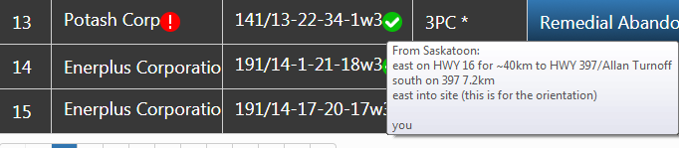

1. OK
2. Let’s leave this one out of scope for now, you may enter them in notes. We will revisit it in later phases if needed.
3. OK.
4. OK.
5. Let’s leave the alert functions out of scope of phase 1. We may consider in later phases.

Update for last one – Colin

1. For these we don’t need it to stand out so much.  It just needs to be there.  These are still too big I think.
2. OK
3. OK
4. OK
5. OK
6. OK